AGENDA - Little Hoole Parish Council
Members of the Council are summoned to the Parish Council Meeting to be held on
Mon 8th April 2024 at 7:15pm (please note the later start time)
The Lounge, Walmer Bridge Village Hall, Gill Lane, Walmer Bridge.
Paul Cafferkey, Clerk & Responsible Financial Officer

- Apologies for absence
- To agree the Minutes of the last Parish Council Meeting
- To receive declarations of interest
- Matters arising from the minutes of last meeting
  - Public Time: to invite and listen to issues raised by members of the public
  - Planning Applications:
    - 07/2024/00196/FUL, Land West of Wham Lane Little Hoole, Change of use of land from agricultural to equestrian and erection of two stables with associated equestrian infrastructure for domestic use
    - 07/2024/00188/FUL, Moss View Farm Wham Lane Little Hoole, Retrospective change of use of land to private garden
    - 07/2024/00203/DIS, Avondale Dob Lane Walmer Bridge PR4 4SU, Discharge of condition 15 (Contaminated Land) of planning permission 07/2023/00232/FUL
    - 07/2024/00158/CLD, 45 Tillage Close Walmer Bridge PR4 5BZ, Application for a Lawful Development Certificate for a proposed single storey rear extension
  - To approve the following transactions in the bank for Mar 2024.

Current a/c March 2024
Date | Payee | £ | Description
01-Mar-24 | Direct Debit (GOCARDLESS) | 36.96 | Monthly website subscription
19-Mar-24 | B/P to: Paul Cafferkey | 188.92 | Clerk's Salary Tax Month 12
19-Mar-24 | B/P to: Paul Cafferkey | 3.80 | Clerk's Expenses Tax Month 12
27-Mar-24 | B/P to: Lancs Best Kept | 25.00 | Entry Fee Best Kept Village
28-Mar-24 | B/P to: Lancashire County | 191.23 | Relocation of SPiD
31-Mar-24 | Service Charge | 18.00 | Bank Q4 Service Charge
Instant Access a/c March 2024
31-Mar-24 | Credit Interest | -131.47 | Bank Q4 Interest

  - Payments for approval - Clerk’s claim for Mar 2024
  - Payments approved by email or pre-approved and retrospectively noted - None
  - To approve financial statement as at 31st March 2024
  - To approve HR Policies
  - To finalise and agree parish council meeting dates for remainder of calendar year
  - Summer Activity Programme – Update
  - Wild Flower Area, Dob Lane Recreation Park - Update
  - Summer Planting - Update
  - Correspondence, None
  - Information and Updates
  - To vote upon candidate to be co-opted to fill parish councillor vacancy (public to be excluded for this item)
  - To agree the date, time and venue for the May 2024 meeting

Members of the public are welcome to attend meetings to raise any relevant matters. Alternatively, if you cannot attend the meeting but wish to raise a matter or ask a question, this can be done on your behalf by contacting the Parish Clerk (Paul Cafferkey) via email at clerk@littlehooleparishcouncil.org.uk or mobile phone 07966267186.

Scan me to go the Little Hoole Parish Council Website, or visit https://www.littlehooleparishcouncil.org.uk/
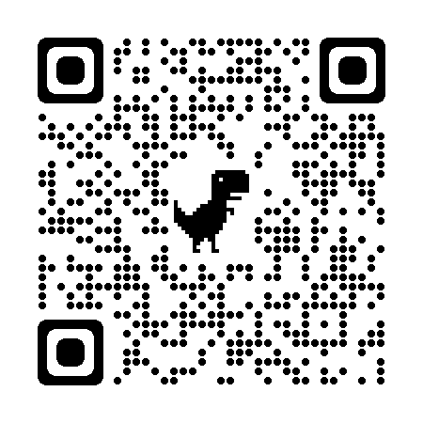
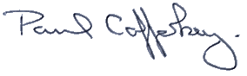
Prepared and approved by Paul Cafferkey, Clerk – Little Hoole Parish Council,
2nd April 2024

